Известия Гомельского государственного университета
имени Ф. Скорины, №6(39), 1, 2006

УДК 621.378.82

Nonlinear reflection of light by thin-film resonant system

E. V. Glasunova, V. A. Yurevich

In the special scientific press nonlinear optical properties of subsurface films of resonant atoms were considered. It is known, that similar films, and also planar structures on their basis, are especially sensitive to phase characteristics of laser radiation [1,2]. In this connection in conditions of field phase modulation dynamic effects are rather possible at interaction of active films with a lasing field [3-5].
The resonator represents optical system, reflection and transmission which also is sensitive to frequency of external radiation. In this connection the study of consequences of coherent light field self-modulation in the optical structure including the thin-film resonator and subsurface layer of substance with resonant polarization (that film adjoins to one of cavity mirrors) is represented interesting. The combination of components with a various degree of criticality in relation to amplitude and a phase of external probing radiation, obviously, should be shown in special dependences of film system nonlinear reflection on lasing intensity.
In this paper the thin layer of resonant atoms, which thickness l is much less than length of a wave of light $\left(l\text{<<}λ\right)$ is considered. On a surface of layer the flat light wave with frequency $ω=2π/λ$ and slow amplitude $E_{i}\left(t\right)$is normally falls. In super-thin layer approximation of light field interaction with substance of the resonant polarizable film dividing the media with permeabilties $e_{1}$and$e_{2}$(fig.1, right border), is described similarly [6] by modified system of Maxwell-Bloch equations.
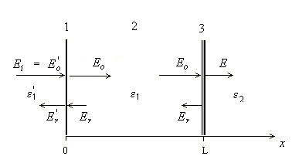

Fig.1. Schematic diagram of a thin-film resonator: (1) left reflecting border, (2) non-active layer, (3) right border with thin subsurface active film.

Stationary approximation of that computing model enables to write down the following expression for values of the established field amplitudes ($E_{i}\left(t\right)=E_{i}=\text{const}$):
$$\left[1+\frac{κ}{1+{\left(Δ+Δ_{s}\right)}^{2}+I}\right]⋅E_{s}=\frac{2\sqrt{ε_{1}}}{\sqrt{ε_{1}}+\sqrt{ε_{2}}}E_{0}− i \frac{κ\left(Δ+Δ_{s}−βI\right)}{1+{\left(Δ+Δ_{s}\right)}^{2}+I}{\text{ E}}_{s}\text{ ,}$$
where E_{S} − the amplitude of a stationary field normalized to a level of sating capacity of a field (in such a case $I={\left|E_{S}\right|}^{2}=\frac{μ^{2}}{ℏ^{2}}T_{1}T_{2}{\left|E_{s}\right|}^{2}$- dimensionless stationary field intensity inside a film), μ − dipole moment matrix element of transition, T₁ and T₂ − times of longitudinal and cross-section relaxation, κ − nonsaturated value of an active film absorption index on resonance frequency ω = ω₀, β − parameter of a resonant nonlinear refraction, $Δ_{s}=β\frac{T_{2}}{2T_{1}}{\left|E_{S}\right|}^{2}−$ Stark drift of resonance frequency, $Δ=\left(ω−ω_{0}\right)T_{2}−$ the normalized defect of a resonance. In a case only Fresnel transmission the correlation between amplitudes of probing (E_{i} = E₀) and past field (inside of a film) is trivial $\begin{matrix}− & E_{s}=\frac{2\sqrt{ε_{1}}}{\sqrt{ε_{1}}+\sqrt{ε_{2}}}E_{0}\text{.}\end{matrix}$ The account of resonant and quasi-resonant polarizabilities in the temporal scale exceeding times of transition relaxation T₁ and T₂, entails the occurrence of nonlinear components in the resulted expression. Those real and imaginary (phase) components are additional in relation to Fresnel part. Their presence describes change in character of phase-sensibility of medium with subsurface active layer which, in particular, should be expressed in definite features of its transmission dependence from intensity of a probing light field.
The ratio for field amplitudes allows to write down the expression connecting stationary values of normalized intensity:
$I_{0}\frac{4ε_{1}}{{\left(\sqrt{ε_{1}}+\sqrt{ε_{2}}\right)}^{2}} = I\left\{{\left[1+\frac{κ}{1+{\left(Δ+Δ_{s}\right)}^{2}+I}\right]}^{2}+κ^{2}{\left[\frac{Δ−β \left(1−{T_{2}}/2T_{1}\right)I}{1+{\left(Δ+Δ_{s}\right)}^{2}+I}\right]}^{2}\right\} \text{.}$ (1)
The analysis of surface polarization influence on transmission of normally falling monochromatic light wave by submicronic active film on border between optical media was carried out, for example, in [6,7].
Here is solved the problem of study of its contribution to reflection of a lasing field from an non-active dielectric layer forming the cavity - two plane-parallel surfaces with various reflection indexes, to one of those surfaces the film of active atoms adjoins (fig. 1). We assume further, that nonlinear reflection occurs on border х = L of a layer with ε₁. For border layer (х = 0) typically “usual” Fresnel reflection. Light wave normally falling on an active film is characterized by amplitude $E_{0}=\left(1−r'\right)E'_{0},$ where $r^{'}=\frac{\sqrt{ε_{1}^{'}}−\sqrt{ε_{1}}}{\sqrt{ε_{1}}+\sqrt{ε_{1}^{'}}}$ - amplitude reflection index of first of borders of a layer. Similarly (1) correlation for amplitudes of the probing, past and reflected wave is received:
$$E_{r}= \begin{matrix}\frac{\sqrt{ε_{2}}−\sqrt{ε_{1}}}{\sqrt{ε_{1}}+\sqrt{ε_{2}}}E_{0}− \frac{κ}{1+{\left(Δ+Δ_{s}\right)}^{2}+I}\left[1 + i\left(Δ+Δ_{s}−βI\right)\right]{\text{ E}}_{s} & \text{.}\end{matrix}$$
The effective amplitude reflection index is represented, thus, as the complex value dependent on intensity of a field $E_{S},$ which acting inside active layer:
(2)
Here amplitude reflection index of second one of cavity mirrors. The module of effective reflection index can be designed from expression:
(3)
where the value of $T=\left|\frac{E_{s}}{E_{0}}\right|$ is determined from expression (1):
$$T=\frac{2\sqrt{ε_{1}}}{\sqrt{ε_{1}}+\sqrt{ε_{2}}}{\left\{{\left[1+\frac{κ}{1+{\left(Δ+Δ_{s}\right)}^{2}+I}\right]}^{2}+κ^{2}{\left[\frac{Δ−β\left(1−{T_{2}}/2T_{1}\right)I}{1+{\left(Δ+Δ_{s}\right)}^{2}+I}\right]}^{2}\right\}}^{−1/2}\text{.}$$
Complex character of expression (2) means, that under condition of reflection from a subsurface layer with resonant polarisation the light field should get nonlinear phase shift Δφ, estimated as
(4)
Proceeding from magnitude I (intensity of a field acting on active atoms inside the super-thin film), effective reflection and arising due to resonant and quasi-resonant polarisations nonlinear phase shift of the reflected wave on second one of cavity mirrors is defined, following expressions (3), (4). The effective power reflection index of resonator with the account of an interference of counter waves in a stationary regime of light action can be defined from a well-known expression (see, for example, [8]):
$\begin{matrix}r & & \frac{r'^{2}+R^{2}+2r'\left|R\right| \text{cos}\left(2ωL\sqrt{ε_{1}}/c−Δϕ\right)}{1+{\left(r'R\right)}^{2}+2r'\left|R\right| \text{cos}\left(2ωL\sqrt{ε_{1}}/c−Δϕ\right)} & \text{.}\end{matrix}$ (5)
Expressons (2) - (5) give a possibility of an estimation of nonlinear reflection index of the micro-resonator formed by a layer of the dielectric medium and a film of active atoms with resonant polarizability. Reflection of such system is critical in relation to frequency ω and a magnitude of probing light field intensity.
The calculation of r which depend on the normalized probing intensity $I_{0}=\frac{μ^{2}}{ℏ^{2}}T_{1}T_{2}{\text{E'}}_{0}^{2}$ is convenient to carry out parameterically – assuming the magnitude of I as non-negative linearly increasing variable. Values of $R, Δϕ\text{, }I_{0}=IT^{2},$ which are necessary for dependence estimation, are calculated as function of variable I. We shall note also, that for dielectric and semiconductor media - $\begin{matrix}T_{2} & \text{<<} & T_{1}\end{matrix},$ therefore expressions (2) - (5) became rather simpler, in such a case the Stark component of the nonlinear detuning is negligible. In general, film spectroscopic and relaxation parameters used in expressions (2) - (5) at the computing of a dependence r(I₀) resolution corresponded in to semiconductor media which usually used in devices of optics and laser physics. Thickness of the layer - resonator in our case is rather insignificant - L ~ 1·10⁻⁴m.
Figure 2 illustrate the result of effective micro-resonator reflection index computation basing on expressions (2) - (5). Being based on similar results, the following conclusions are possible. Reflection from the resonator including a thin layer with surface polarization, on character is nonlinear, i.e. depends on a probing light wave intensity. The curves describing such dependence, are characterized by an extremum - at the certain intensity I₀ the reflection index r is minimal. At the further increase in input power of radiation there is a saturation of value r. The sated size of reflection r_{s} is determined final nonzero the frequency detuning. The magnitudes of that detuning and corresponding reflection r_{s} dependent, basically, upon values of indexes κ and β.
It is especially important that reflected by the resonator with a nonlinear subsurface layer the wave gets nonlinear phase shift. The nonlinear drift arising during action on the resonator of pulse radiation of lasers, should determine peak transformation of a laser field. This phenomenon is perspective at creation on the basis of the thin-film structures similar considered, so-called chirping reflectors, used in laser devices for reduction of the reflected pulses duration.
By the data of fig. 2 the position of an extremum r on scale I₀ and the sated value r_{s} depend on indexes of resonant absorption and a nonlinear refraction, and also upon frequency detuning of probing radiation in relation to frequency of an optical resonance. Therefore the analysis of really registered dependences r(I₀) can be used for purposes of comparative estimation or definition of these film parameters. There is an indisputable importance of calculations which here carried out above for development of the technique of the diagnostics of submicronic active film optical properties.
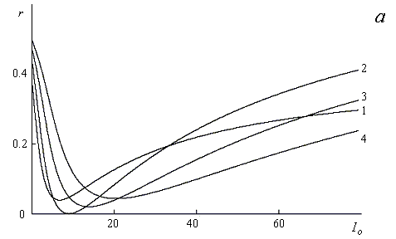
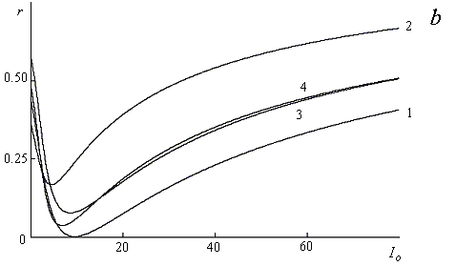
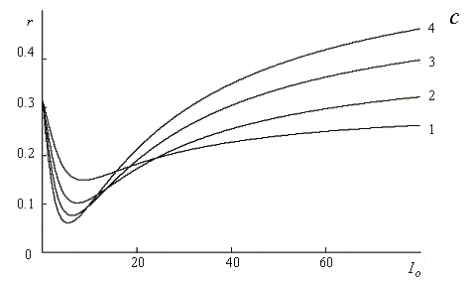

Fig.2. Plots of the effective reflection index r versus normalized probing intensity I₀:
(a) for various values of the nonlinear asorption parameter κ = 0.6 (1), 1.4 (2), 2.2 (3), 3.0 (4) and Δ = 0.4, β = 2.5, (b) for various values of resonance defect Δ = 0.4 (1), 0.45 (2), 0.9 (3), 0.95 (4) and κ = 1.5, β = 2.5, (c) for various values of parameter of a resonant nonlinear refraction β = 1.0 (1), 1.5 (2), 2.0 (3), 2.5 (4) and κ = 0.8, Δ = 0, L = 5·10⁻⁴ m.

Acknowledgement. This work is supported by Belarussian Foundation for Fundamental Research (Project No Ф06М-231) and RB Education Ministry Foundation for Fundamental Research (Project No 126-06).
Abstract. Results of computational study of light phase-amplitude self-modulation in bleachable film structures are submitted. The structure is consisted of the micro-resonator (a thin dielectric layer) and the submicronic subsurface film of resonant atoms adjoining to one of reflecting borders of a layer. The minimum is inherent in intensity reflection index dependence of such system, its characteristics depend on film parameters of a nonlinear absorption and refraction.

References

1. V.I.Rupasov and V.I.Yudson, Kvantovaya Électron. (Moscow) 9, 2179 (1982).
2. S. M. Zakharov, É. А. Manykin, ZhÉTPh (Moscow) 105, 1053 (1994)
3. I. V. Babushkin, Y. A. Logvin, N.A.Loǐko, ZhÉTPh (Moscow) 117, 149 (2000)
4. I. V. Babushkin, P. V. Pavlov, N.A.Loǐko, Kvantovaya Électron. (Moscow) 34, 355 (2004)
5. E. V. Glasunova, A.V.Khomchenko, V.A.Yurevich, Proceeding SPIE 6259, 256 (2006)
6. V. A. Yurevich, Zh. Prikl. Spektrosk. 66, 661 (1999)
7. E. V. Glasunova, V. A.Yurevich, Zh. Prikl. Spektrosk. 72, 271 (2005)
8. The Directory on Lasers. Ed. by A. M. Prokhorov. Мoscow: Sov. Radio. 1984. V.1. – 484 p.

Department of Experimental and Theoretical Physics,
Mogilev State University Поступило 11.09.06

